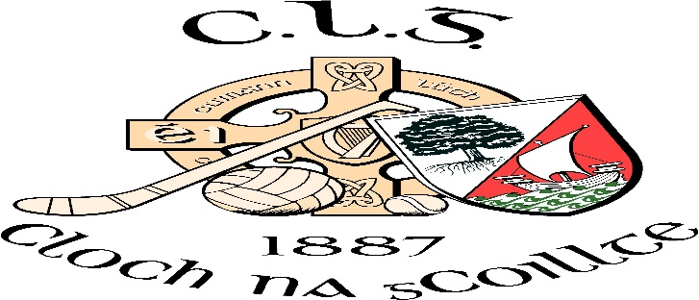

The Big Hello Get Together at Clonakilty GAA Club

The Big Hello! is a national community weekend of community celebration. The aim of the weekend is to encourage people to get together to connect and to get to know their neighbours.
Clonakilty GAA Club in partnership with Cork GAA Health and Wellbeing and Cork County Council are hosting a get together at Ahamilla on Saturday 4th May from 11am to 2pm. While everyone is more than welcome, we are targeting the senior members of the community.
We will be serving complimentary tea/coffee, scones/cakes and we will have a talk by Maurice Moore on mobility and exercise. In addition we will have board games and live music.
We will run shuttle buses to and from the event from Clonakilty town and further details of the bus services will be published closer to the event,
If you are interested in attending or if you are involved with any group that may like to attend the event, contact Ger McCarthy on 086 8532137 or email ahamilla@gmail.com for further details and transport arrangements

